MLA0105 - Artificial Intelligence and Expert Systems for Gaming
Experiment 31: Who loves whom
Code:
loves(john, mary).
loves(jane, peter).
loves(peter, alice).
loves(john, alice).
Output:
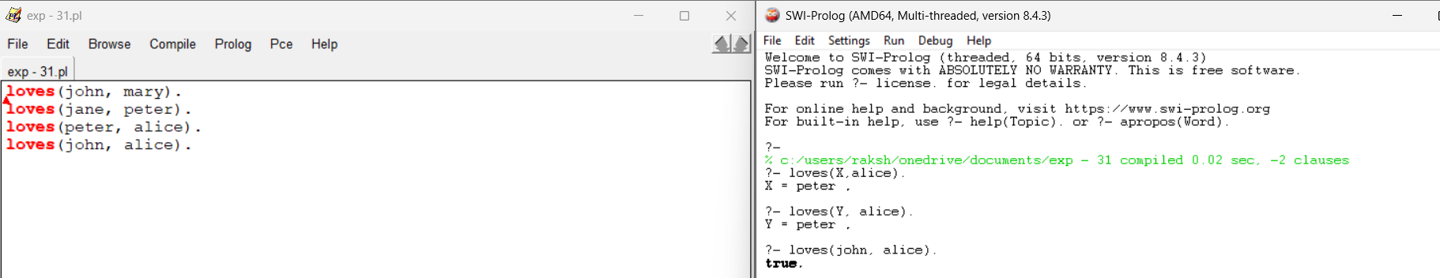
Experiment 32: Location
Code:
location(Chennai, tamilnadu).
location(Tirupati, andhrapradesh).
stays(ravi, chennai).
stays(Raksha, Tirupati).
display(person, city, state):-
stays(person, city),
location(city, state).
state_of_person(person, state):-
stays(person, city),
location(city, state).
Output:
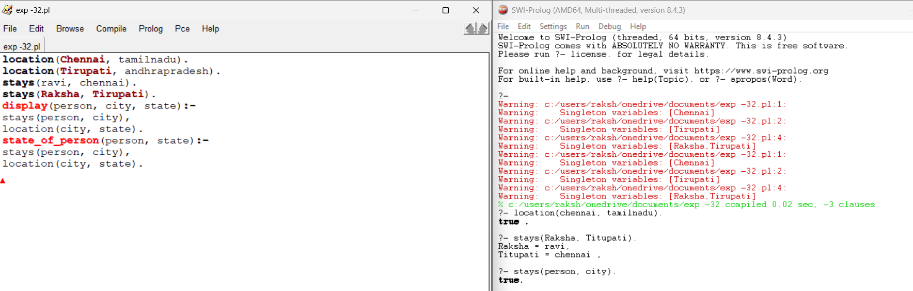
Experiment 33: Family members and Relationships
Code:
parent(john, bill).
parent(linda, bill).
parent(john, alice).
parent(linda, alice).
parent(bill, bob).
parent(alice, sue).
parent(tom, marry).
parent(susan, marry).
parent(bob, sam).
male(john).
male(bill).
male(bob).
male(tom).
male(sam).
female(linda).
female(alice).
female(sue).
female(marry).
female(susan).
sibling(X, Y):-
parent(P , X),
parent(P , Y),
X\=Y.
brother(X, Y):-
sibling(X, Y),
male(X).
sister(X, Y):-
sibling(X, Y),
female(X).
father(X, Y):-
parent(X , Y),
male(X).
mother(X, Y):-
parent(X , Y),
female(X).
grandparent(X, Y):-
parent(X , Z),
parent(Z , Y).
grandmother(X, Y):-
grandparent(X, Y),
female(X).
grandfather(X, Y):-
grandparent(X, Y),
male(X).

Output:
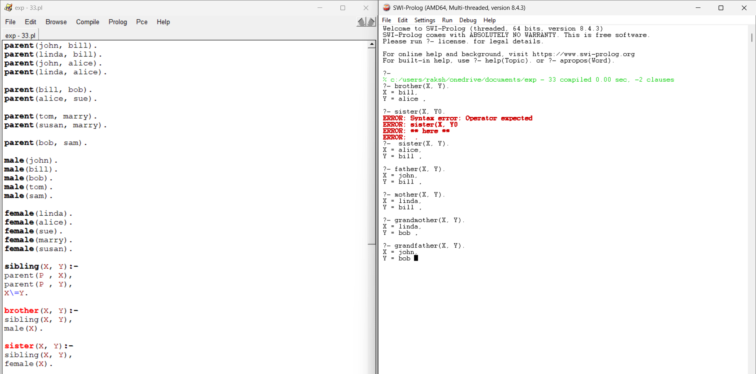
Experiment 34: Boy or Girl
Code:
child(X) :- boy(X).
child(X) :- girl(X).
gets(X, doll) :- child(X).
gets(X, train) :- child(X).
gets(X, coal) :- child(X).
gets(X, doll) :- \+ boy(X).
gets(X, coal) :- child(X), \+ good(X).
boy(jack).
Output:
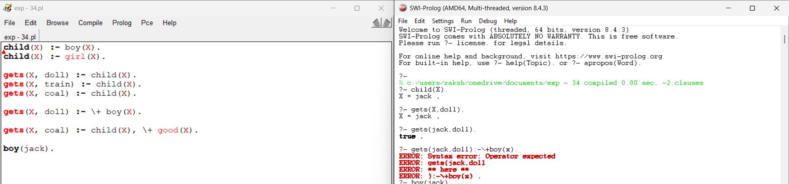
Experiment 35: Celsius to Fahrenheit
Code:
c_to_f(C, F) :-
F is (C * 9/5) + 32.
below_freezing(C) :-
C<0.
Output:
